**What is IP Address :**

* **IP** (Internet Protocol) Addresses are the unique numbers assigned to every computer or devices to communicate with each other.
* A unique address that identifies the device over the network.
* They are mode up of a series of number or alphanumeric character that help us to identify device on a network.

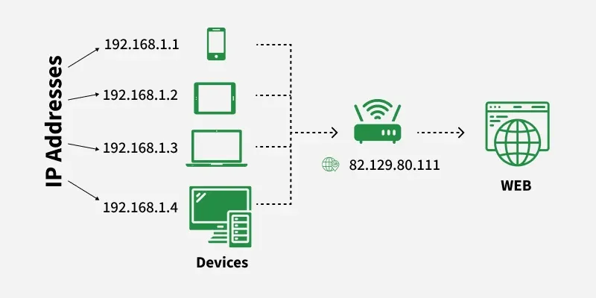

**Components of an IP Address :**

* **Network Portion:**Identifies the network to which the device belongs**.**
* **Host Portion:**Identifies the individual device on the network.
* **Subnet Mask (for IPv4):**Defines which part of the IP is network and which part is host.
* *Example: IP 192.168.1.10 with subnet mask 255.255.255.0  
  Network ID: 192.168.1.0  
  Host ID: 10*

**Types of IP Address**

* IP addresses can be classified in several ways based on their structure, purpose, and the type of network they are used in. Here's a breakdown of the different classifications of IP addresses.

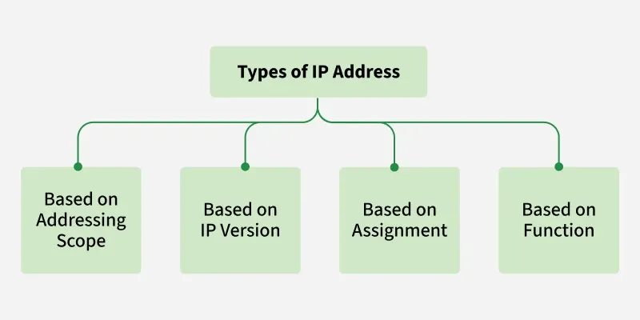

**1. Based on Addressing Scope (IPv4 vs. IPv6)**

**1.1 Public IP Addresses**

A Public IP address is assigned to every device that directly accesses the internet. This address is unique across the entire internet. Uniqueness & Accessibility are its key characteristics & are assigned by Internet Service Providers. When you connect to the internet through an ISP, your device or router receives a public IP address. These addresses can be static or dynamic.

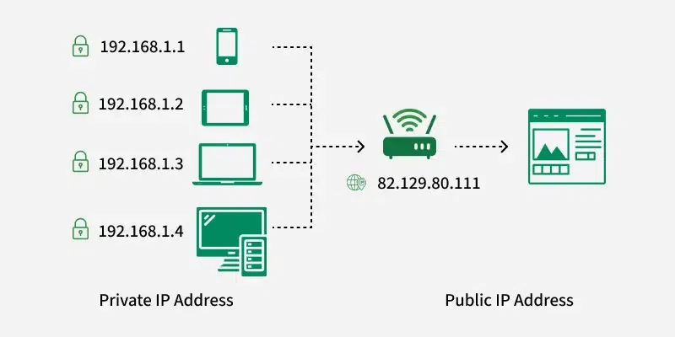

**1.2 Private IP Addresses**

Private IP addresses are used within private networks and are not routable on the internet. This means that devices with private IP addresses cannot directly communicate with devices on the internet without a translating mechanism like a router performing Network Address Translation (NAT). These are only required to be unique within their own network & are used for communication between devices within the same network

* **Defined ranges for IPv4:**10.0.0.0 to 10.255.255.255, 172.16.0.0 to 172.31.255.255, 192.168.0.0 to 192.168.255.255
* **Defined ranges for IPv6:** Addresses starting with FD or FC

**2. Based on IP Version**

**2.1 IPv4**

This is the most common form of IP Address. It consists of four sets of numbers(octets) separated by dots. This format can support over 4 billion unique addresses. Each octet represents eight bits, or a byte, and can take a value from 0 to 255. This range is derived from the possible combinations of eight bits (28 = 256 combinations).

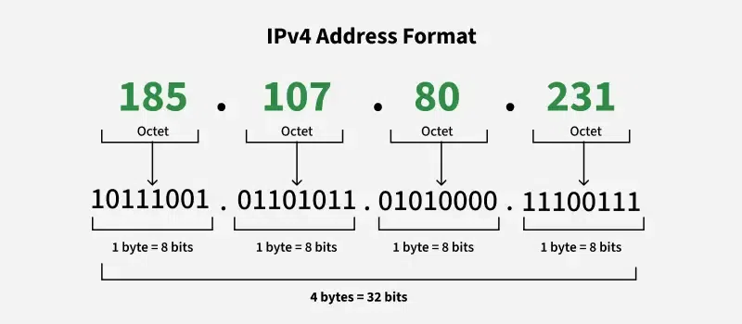

**Example of IPv4 Address**: $192.168.1.1$

* 192 is the first octet
* 168 is the second octet
* 1 is the third octet
* 1 is the fourth octet

**2.2 IPv6:**

IPv6 addresses were created to deal with the shortage of IPv4 addresses. They use 128 bits instead of 32, offering a vastly greater number of possible addresses. These addresses are expressed as eight groups of four hexadecimal digits, each group representing 16 bits. The groups are separated by colons.

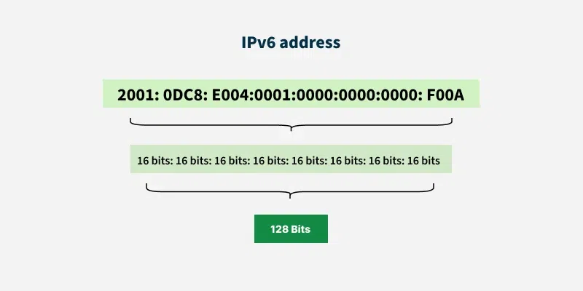

**3. Based on Assignment**

**3.1 Static IP Addresses**

* Static IP Addresses are permanently assigned to a device, typically important for servers or devices that need a constant address.
* Reliable for network services that require regular access such as websites, remote management.

**3.2 Dynamic IP Addresses:**

* Temporarily assigned from a pool of available addresses by the Dynamic Host Configuration Protocol (DHCP).
* Cost-effective and efficient for providers, perfect for consumer devices that do not require permanent addresses.

**4. Based on Function**

**4.1. Unicast Address**

In unicast, data is sent from one sender to one specific receiver identified by a unique IP address. It is the most common type of communication used in networks. Its Purpose is One-to-one communication.

* **Example:** Sending an email or loading a webpage - your computer directly communicates with a specific server.
* **Use Case:** Regular web browsing, file transfers (FTP), email (SMTP), etc.

**4. 2. Broadcast Address**

In broadcast, a message is sent from one device to all devices in the same network segment. Every device in the network receives and processes the broadcast message. Its Purpose is One-to-all communication within a network.

* **Example:** An ARP (Address Resolution Protocol) request uses broadcasting to find a device’s MAC address on the local network.
* **Use Case:** Network discovery, DHCP requests, ARP queries

**4. 3. Multicast Address**

In multicast, data is sent from one source to multiple selected receivers that are part of a multicast group. Only devices that have joined the group will receive the data, making it more efficient than broadcasting. Its Purpose is One-to-many (selected group) communication.

* **Example:** Streaming live video or online conferencing to a group of users.
* **Use Case:** IPTV, video conferencing, live streaming
* **IPv4 Range: $224.0.0.0$** to $239.255.255.255$
* **IPv6 Prefix: $FF00::/8$**

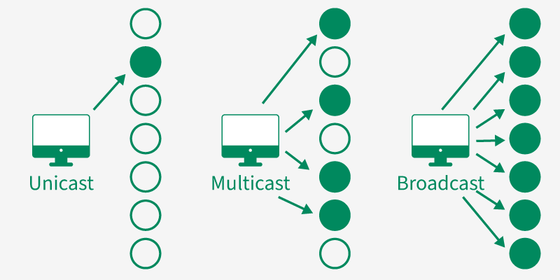

**4.4. Anycast Address**

In anycast, data is sent from one sender to the nearest receiver (in terms of network distance) among a group of devices sharing the same IP address. Routers determine the closest destination dynamically. Its Purpose is One-to-nearest communication (based on routing distance).

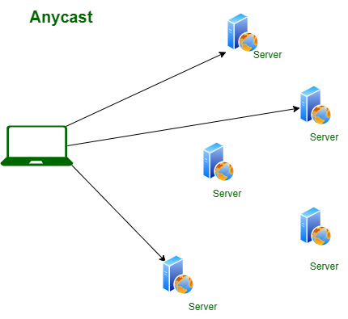

* **Example:** Content Delivery Networks (CDNs) use anycast to route user requests to the nearest data center.
* **Use Case:** DNS servers, CDN routing, load balancing

IP version :

|  |  |  |
| --- | --- | --- |
| IP version | Description | Status |
| 0 |  | Reserved |
| 1-3 |  | Unassigned |
| 4 | Internet Protocol version 4 (IPv4) | Active |
| 5 | Internet Stream Protocol or ST | Obsolete, Superseded by ST-II |
| 5 | Internet Stream Protocol or ST-II | Obsolete |
| 6 | Simple Internet Protocol (SIP) | Obsolete, merged into IPv6 |
| 6 | IPv6 | Active |
| 7 | TP/IX The Next Internet (IPv7) | Obsolete |
| 8 | P Internet Protocol (PIP) | Obsolete, merged into SIP in 1993 |
| 9 | TCP & UDP over bigger Address (TUBA) | Obsolete |
| 9 | IPv9 | April fools day joke |
| 10-14 |  | Unassigned |
| 15 |  | Reserved |

* IP Addresses are globally managed by Internet Assigned Number Authority (ISNA) and Regional Internet Registries (RIR)
* While finding the total no. of host IP addresses , 2 IP Address not counted because the 1st IP Address of any network is the network number and last IP Address is reserved for broadcast IP.

**Classful Addressing :**

* The 32- bit IP Address is divided into five sub-classes.
* Class A
* Class B
* Class C
* Class D
* Class E
* IP addresses were divided into five classes (A, B, C, D, E), identified by their first few bits and designed for specific purposes.
* Classes A, B, C Used for unicast communication (large, medium, and small networks).
* Class D Reserved for multicasting.
* Class E Experimental use.
* The class of IP address is used to determine the bits used for network ID and Host ID and the number of total networks hosts possible in that particular class.
* Each ISP or network administrator assigns an IP address to each device that is connected to it network.

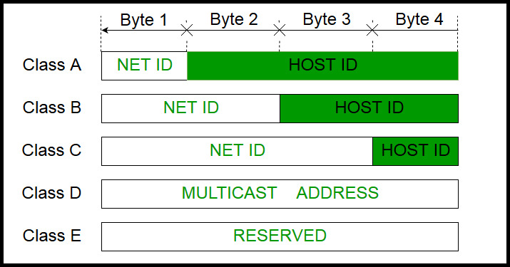

1. **Class A :**

* IP Addresses belonging to class A are assigned to the network that contain a large number of hosts.
* The network ID is **8** bits long.
* The host ID is **24** bits long.
* The higher-order bit of the first octet in class A is always set to 0. The remaining 7 bits in the first octet are used to determine network ID.
* The 24 bits of host ID are used to determine the host in any network.
* The default subnet mask for Class A is 255.x.x.x. Therefore, class A has a total of:
* 224 - 2 = 16,777,214 host ID
* IP addresses belonging to class A ranges from 0.0.0.0 - 127.255.255.255.

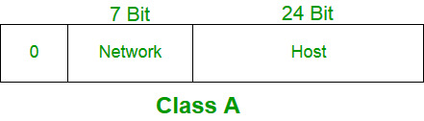

1. **Class B :**

* IP address belonging to class B is assigned to networks that range from medium-sized to large-sized networks.
* The network ID is 16 bits long.
* The host ID is 16 bits long.
* The higher-order bits of the first octet of IP addresses of class B are always set to 10.
* The remaining 14 bits are used to determine the network ID.
* The 16 bits of host ID are used to determine the host in any network.
* The default subnet mask for class B is 255.255.x.x. Class B has a total of:
* 214 = 16384 network address
* 216 - 2 = 65534 host address
* IP addresses belonging to class B ranges from 128.0.0.0 – 191.255.255.255.

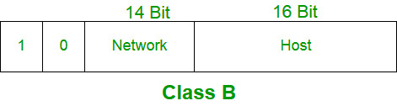

1. **Class C :**

* IP addresses belonging to class C are assigned to small-sized networks.
* The network ID is 24 bits long.
* The host ID is 8 bits long.
* The higher-order bits of the first octet of IP addresses of class C is always set to 110.
* The remaining 21 bits are used to determine the network ID.
* The 8 bits of host ID are used to determine the host in any network.
* The default [subnet mask](https://www.geeksforgeeks.org/computer-networks/role-of-subnet-mask/) for class C is 255.255.255.x. Class C has a total of:
* 221 = 2097152 network address
* 28 – 2 = 254 host address
* IP addresses belonging to class C range from 192.0.0.0 – 223.255.255.255.

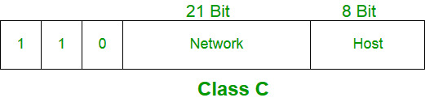

**4.Class D :**

* IP address belonging to class D is reserved for [multi-casting](https://www.geeksforgeeks.org/computer-networks/multicasting-in-computer-network/).
* The higher-order bits of the first octet of IP addresses belonging to class D is always set to 1110.
* The remaining bits are for the address that interested hosts recognize.
* Class D does not possess any subnet mask.
* IP addresses belonging to class D range from 224.0.0.0 – 239.255.255.255.

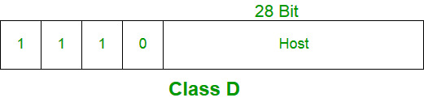

**5.Class E :**

* IP addresses belonging to class E are reserved for experimental and research purposes.
* IP addresses of class E range from 240.0.0.0 – 255.255.255.255.
* This class doesn’t have any subnet mask.
* The higher-order bits of the first octet of class E are always set to 1111.

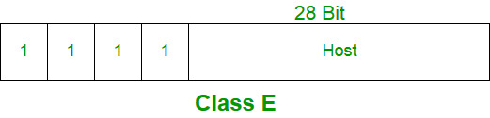

**Range of Special IP Addresses**

* ***169.254.0.0 – 169.254.0.16*** *: Link-local addresses*
* ***127.0.0.0 – 127.255.255.255*** *: Loop-back addresses*
* ***0.0.0.0 – 0.0.0.8****: used to communicate within the current network.*

**Structure of Classful Addressing**

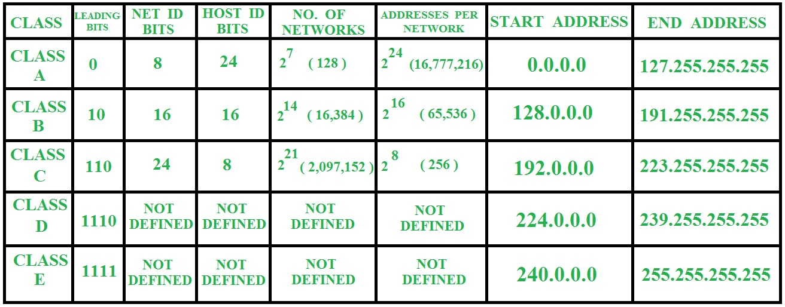

**Classless Addressing**

* To reduce the wastage of IP addresses in a block, we use sub-netting.
* What we do is that we use host id bits as net id bits of a classful IP address.
* We give the IP address and define the number of bits for mask along with it (usually followed by a '/' symbol), like, 192.168.1.1/28.
* Here, subnet mask is found by putting the given number of bits out of 32 as 1, like, in the given address, we need to put 28 out of 32 bits as 1 and the rest as 0, and so, the subnet mask would be 255.255.255.240.
* A classless addressing system or classless interdomain routing (CIDR or supernetting) is the way to combine two or more class C networks to create a/23 or a /22 supernet.
* A classless addressing system or classless interdomain routing (CIDR) is an improved IP addressing system.
* In a classless addressing system the block of IP address is assigned dynamically based on specific rules.

For ex –

-192.168.1.0/24

* This notation indicates that the first 24 bits of the IP Address are the network ID prefix and the remaining 8 bit are the host identifier.
* **Rules :**
* Address should be contiguous.
* Number of addresses in a block must be in power of 2 (n2).
* 1st address of every block must be evenly divisible with size of block.

**Subnet :**

* Subnetting is the process of dividing a large network into smaller network called “Subnet”.
* Subnets provide each group of devices with their own space to communicate , which ultimately helps the network to work easily.
* Subnet makes the network faster and easier to manage and also improve the security of the network.

What is subnet mask ?

* A subnet mask is a 32 – bit number that separates an IP addresses into two parts :
* Network ID
* Host ID
* Subnet mask help divide a large network into smaller sub-networks improving network , efficiency, security and performance.

